**Sales Forecasting Dashboard Project Report**

**Prepared by:** Haward Felix

**Date:** 9th/July/2024

**1. Introduction**

This report details the development of a comprehensive sales forecasting dashboard using Power BI. The dashboard is designed to provide insightful visualizations and predictive analytics to aid decision-making processes in sales management.

**2. Project Overview**

**2.1 Objectives**

* To analyze historical sales data and identify trends.
* To forecast future sales based on historical data.
* To create an interactive dashboard for monitoring key sales metrics.
* To provide a tool that helps in strategic planning and decision-making.

**2.2 Scope**

The project covers:

* Data preparation and cleaning.
* Data modeling using DAX (Data Analysis Expressions).
* Visualization of historical and forecasted sales data.
* Implementation of interactive features for enhanced user experience.

**3. Data Preparation**

**3.1 Data Collection**

Data was collected from the company’s sales database, including:

* Sales transactions
* Product details
* Customer information
* Sales regions

**3.2 Data Cleaning**

The data was cleaned to ensure accuracy and consistency:

* Removal of duplicates
* Handling missing values
* Standardizing date formats

**3.3 Data Loading**

Data was loaded into Power BI for further processing.

**4. Data Modeling**

**4.1 Creating Calculated Columns**

Calculated columns were created to add new data fields:

* **Total Sales**: [Quantity] * [Unit Price]

Total Sales = Sales [Quantity] * Sales [Unit Price]

**4.2 Creating Measures**

Measures were used for aggregating data:

**Total Sales**:

Total Sales = SUM (Sales [Total Sales])

**Monthly Sales**:

Monthly Sales = CALCULATE (SUM (Sales [Total Sales]),

FILTER (ALL (Sales [Date]),

Sales [Date] >= STARTOFMONTH (Sales [Date]) &&

Sales [Date] <= ENDOFMONTH (Sales [Date])))

**5. Visualization**

**5.1 Visual Elements**

The following visualizations were used to present data effectively:

* **Line Chart**: Historical and forecasted sales trends.
* **Bar Chart**: Sales comparison across products and regions.
* **Pie/Donut Chart**: Proportion of sales by category.
* **Slicer**: Interactive filtering by date, product category, and region.
* **Table/Matrix**: Detailed data view.

.

**5.2 Implementation of Slicers**

Slicers were added to allow users to filter data dynamically:

* Date slicers to select specific time periods.
* Category slicers for product and region selection.

**5.3 Background Customization**

Visual backgrounds were customized to improve aesthetics:

Background colors and transparency were adjusted for clarity.

**6. Sales Forecasting**

**6.1 Built-in Forecasting**

Power BI’s built-in forecasting features were utilized:

Forecast lines were added to line charts to predict future sales based on historical data.

**6.2 Advanced Forecasting (Optional)**

For more sophisticated forecasting, R or Python scripts can be integrated:

Scripts can be written and executed within Power BI to apply advanced statistical methods.

**7. Dashboard Enhancement**

**7.1 Interactive Elements**

Interactive elements such as bookmarks and buttons were added:

Users can drill through data and view detailed insights with a click.

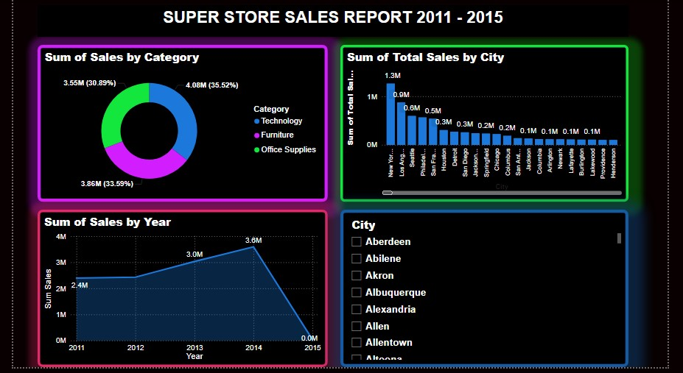

**7.2 Filters and Slicers**

Filters and slicers were implemented for dynamic data exploration:

Users can filter by date, product category, and region to tailor the dashboard to their needs.

**7.3 Annotations and Descriptions**

Annotations and descriptions were added to visuals for better understanding:

Each visual has a clear title and description/tooltips for context.

**8. Publishing and Sharing**

**8.1 Publishing to Power BI Service**

The dashboard was published to Power BI Service for accessibility:

The report was saved and published to the designated workspace.

**8.2 Creating and Sharing Dashboards**

Visuals were pinned to dashboards in Power BI Service:

Dashboards were organized and shared with stakeholders for collaborative use.

**9. Conclusion**

The sales forecasting dashboard developed in Power BI provides a robust tool for analyzing historical sales data and predicting future trends. With its interactive features and comprehensive visualizations, it enhances the ability of sales teams and management to make data-driven decisions.